**FictionEroPhysio Data Collection Guide**

1. **Charge everything**

* Muse
* Bitalino
* Turn on thermometer
* Put not disturb sign on outside of door

1. **Log in** (pass: RxxxL2024)
2. **Open Box (**[**https://sussex.app.box.com/folder/0**](https://sussex.app.box.com/folder/0)**)**

* In FictionEroPhysio folder, open comments
* Fill in participant id, experimenter name, condition (is counterbalanced Interoception or Fiction first, so do the opposite to the previous participant), incentive (credits or money), temperature

1. **Set up Participant’s screen**

* Make sure webcam is in the center ontop of the screen (follow tape markers)
* Open Resting state html (C:\Users\Reality Bending Lab\Desktop\FictionEroPhysio\experiment\RestingState.html)
* Fit lux: temporarily go through the RS html to see the marker for the lux, and securely tape it in this box
* Close and re-open this, fill in participant ID and press continue so it’s on the informed consent page for the participant
* Ensure webcam is in the center of the participant’s monitor
* Ensure volume is on

1. **Set-up signals**

* Open signals: Tick ‘lab streaming layer’ under the integration tab
* Click on the rectangle icon with a green circle, then the dark grey rectangle in the center of the screen
* Ensure ports are RESP (A1) ECG (A2) LUX (A3) EDA (A4)

1. **Set-up Lab recorder**

* Study root = ‘C:\Users\Reality Bending Lab\Desktop\DATA\FEP_data’
* Participant = S00x (check comments file on box)
* Block task = RS 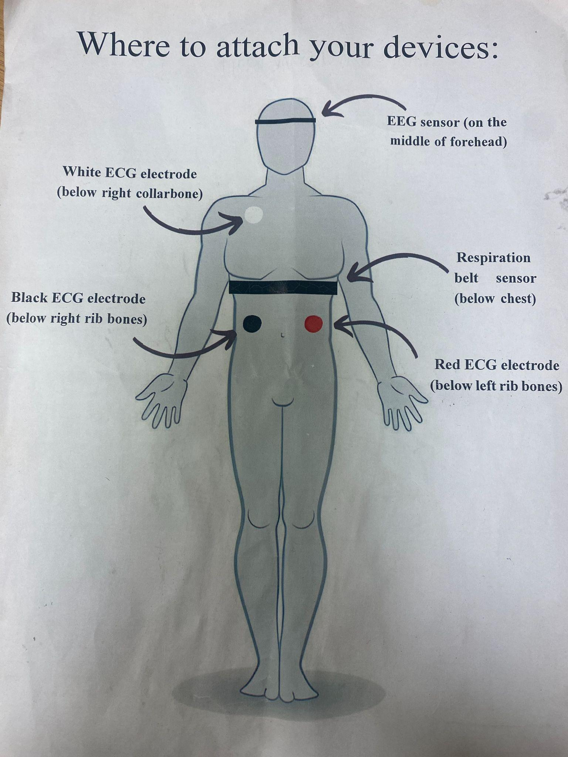

1. **Participant comes**

* Fit sensors:
  + RESP
    - Just below chest: snug fit, sensor to the left on the front of their body just below their chest
    - Ensure no folded cloth by sensor
    - Troubleshooting tips: Ask participant to take a deep breath. Move the sensor to the place on their body that moved the most
    - Check it’s not so tight that participant can feel their pulse
    - Further help: <https://support.pluxbiosignals.com/wp-content/uploads/2021/11/pzt-sensor-datasheet-revb.pdf>
  + ECG
    - Clip electrode sticker on first
    - White: Just below the right collarbone
    - Black: directly below white, just below right ribs. Can suck in the chest to tell where ribs end.
    - Red: parallel to black, in same place below left ribs.
    - As participant to draw a line from the white to red to see if it crosses the heart
    - Troubleshooting tips:
      * Ensure the correct electrode is placed in each position (i.e., white electrode below right collar bone, black electrode below right rib bone, and red electrode below left rib bone)
      * The distance between the white and red electrodes should cross the heart
      * The gap between the white and black electrodes should run in a straight line down the torso
      * Black and red electrodes should be parallel to each other
      * A line crossing the heart should be drawn from the white to the red sensor
    - Further help: <https://support.pluxbiosignals.com/wp-content/uploads/2021/11/ecg-sensor-datasheet-assembled-2.pdf>
  + EDA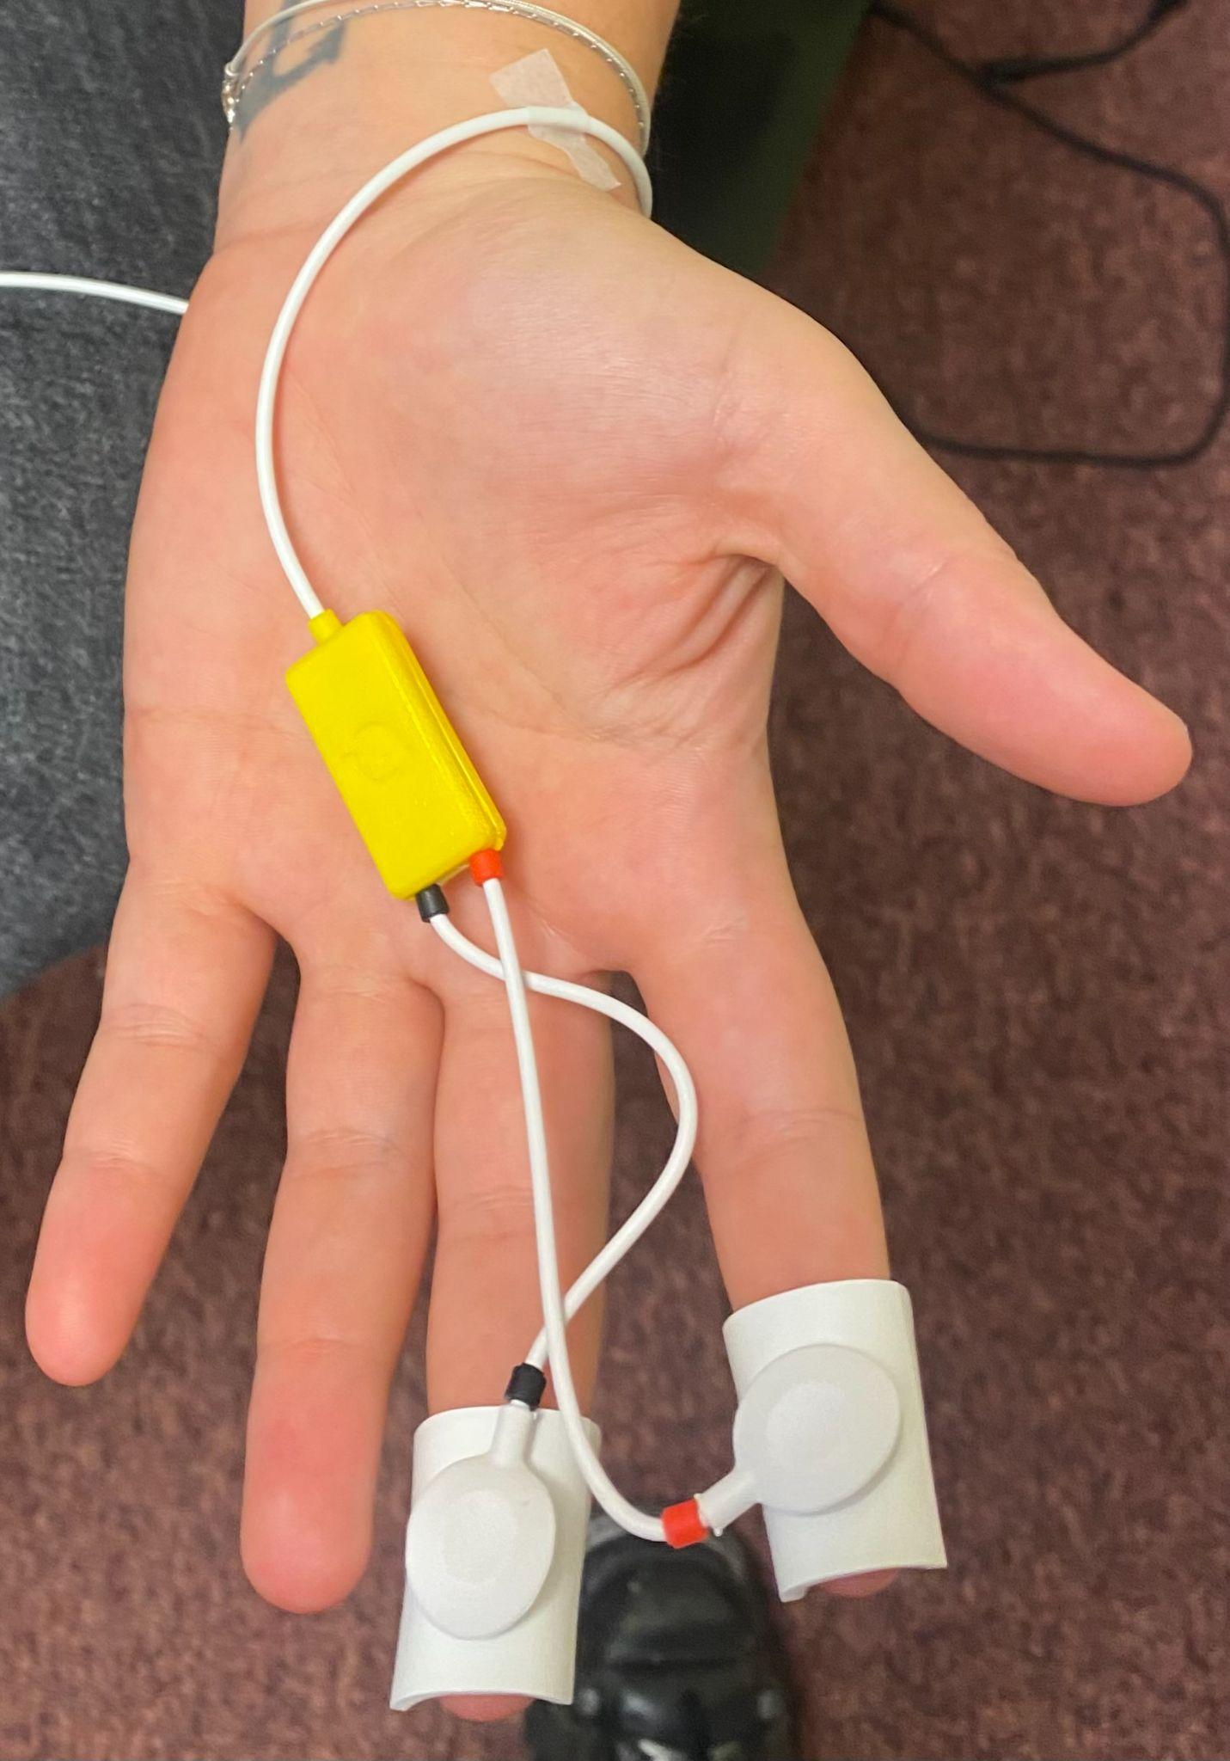-DURING FICTION
* Apply a generous drop of electrode gel.
* Tape the wire by the wrist
* Attach electrodes
* Participant should keep their palm facing up during the experiment
* Check it’s working: ask participant to take a sharp sniff: this should increase EDA. Can also clap loudly in their ear to see if this increases EDA.
* Check it’s not so tight that participant can feel their pulse
* Troubleshooting tips:
  + Hands can’t be cold: Can warm participant’s hand under warm water
  + Reconnect wire from bitalino
  + Replace electrode stickers
  + Add more gel: can use a syringe to put more gel underneath the sponge without taking it off the participant’s finger
* Tips
  + Some people don’t have skin conductance response, and may not respond to all stimuli.
  + Baseline can naturally change during the experiment, this is fine just move the arrow up on open signals to keep viewing the wave.
  + EDA responses may decrease through experiment as participant becomes habituated to stimuli.
* Further help: <https://support.pluxbiosignals.com/wp-content/uploads/2021/11/electrodermal-activity-eda-user-manual.pdf>

1. **Turn on bitalino and connect cables**

* RESP (A1) ECG (A2) LUX (A3) EDA (A4)
* Press red circle to view signals
* If bitalino not working - re-plug in bluetooth and reconnect (pass: 1234)
* Press automatic on the right side for each signal
* Drag bar at the bottom towards the left

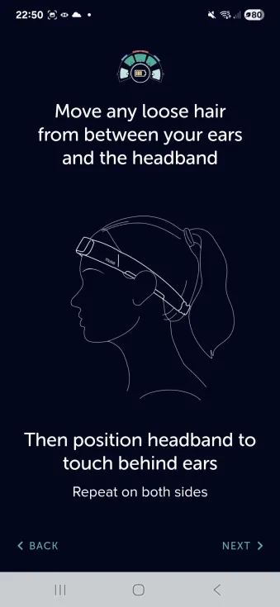

1. **Fit Muse**

* Ask participant to wipe their forehead and above ears
* Remove glasses and tie up hair if applicable
* Clean forehand and above ears with antibacterial wipes
* While loose, clip muse around participant’s neck and lift over the ears.
* Ensure EEG is in the center of the forehead.
* Put hand underneath the Muse athena and pull up hair above the ears on both sides
* Tighten to snug fit

1. **Connect to Muse**

* Vs Code → New terminal
* install the OpenMuse package (dev branch), uninstalling any previous versions (pip uninstall OpenMuse): (pip install https://github.com/DominiqueMakowski/OpenMuse/zipball/dev --upgrade)
* New terminal: (OpenMuse find)
* New terminal: (OpenMuse stream --address 00:55:DA:B9:FA:20 --preset p21 --record " participantid_a.txt” ….participantid_b)
* New terminal: (OpenMuse view)
* Troubleshooting tips:
  + Ensure Bluetooth connections are disabled on all task-irrelevant devices (e.g., nearby phones, headphones, laptops)
  + Make sure no hair is interfering
  + Make sure electrodes are touching the skin
  + Slightly dampen the skin under the electrodes

1. **Check jsPsychMarkers integration (can also find a guide** [**here**](https://github.com/OliverACollins/muse-athena-test) **in README)**

* Ensure that BOTH the recording and experiment machines are connected to the SAME network connection (University ethernet)
* Before running each .html file, check that the IPv4 address for the LSL bridge is correct in EACH .html and relevant .js file. The IPv4 will need changing 3x in each .html file, located at the top of the script. This will most likely need changing every day. You can find the IPv4 address by running the ipconfig command in the VScode terminal on the recording machine
* Before running EACH .html file, run the lsl_bridge.py script (found in the FictionEroPhysio folder) on VScode. This will open up a :5000 port to stream jsPsychMarkers on LabRecorder. You will generally have to run this script TWICE for the :5000 port to open
* Once the :5000 port is open, create a new VScode terminal and run the command: python -m http.server 8000. This will create a **localhost:8000** port on an internet browser to run each .html file
* Now you can run the .html files:

- Resting State: <http://localhost:8000/experiment/restingstate.html>

- Interoception: <http://localhost:8000/experiment/interoception.html>

- Fiction: <http://localhost:8000/experiment/fiction.html>

Expected jsPsychMarkers terminal output:

* RESTING STATE TASK





Troubleshooting for jsPsychMarkers:

* "Error 404" on web browser: when trying to open the **localhost:8000** port, ensure that the VScode terminal working directory leads to the correct path. If it does NOT, use the cd VScode terminal command to rectify
* Markers not sending to VScode “python” terminal: check whether the correct IPv4 address has been added to the .js file(s) used by the .html file

1. **Conduct experiment**

* Always verbally communicate instructions as well as asking participant to read them.
* Ask participant to let you know when they’re done, to manually open the next html file (interoception/fiction)
* Detach the sensor pod and put it on charge during questionnaires (interoception stage) and eye-tracking calibration (fiction stage). After you’ve reconnected, make sure to update lab recorder streams before next recording session.
* Start new recording for each stage, and change name of lab task on lab recorder accordingly (RS- resting state, TAP- tapping tasks, HCT-heartbeat counting task, FP1 - fiction phase 1)

1. **Debrief**

* Thank participant for their time, give debrief sheet, answer questions
* Administer incentive

1. **Add important comments to the comments spreadsheet in Box**

Notes

* Print / online for checklist
* Print debriefing sheet
* fast charger for muse usb c (amazon - black friday)
* Tissues to clean gel from fingers
* Eye tracking data - check patterns
* Change ‘muse 2’ to ‘muse’ on consent

Back to lab recorder

* Update streams (seperate for the muse + bitalino)

**Experimenters:**

* Roisin – Exp1
* Oliver – Exp2
* Ana – Exp3